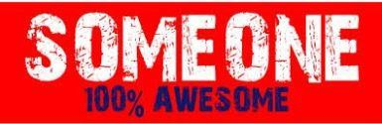Kidswear

STYLE | PHOTO | COLOUR | QUANTITY | RRP
ACHRO-G-02-T | 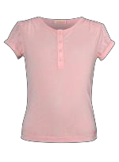 | OLD PINK | 39 | € 19,95
ACHRO-G-15-P | 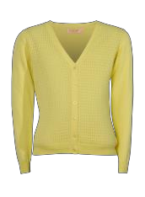 | LIGHT YELLOW | 17 | € 34,95
ACHRO-G-15-S | 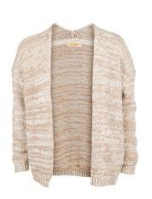 | ECRU | 204 | € 44,95
 | 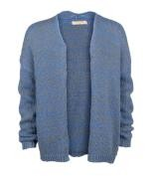 | JEANS BLUE | 118 | € 44,95
ACHRO-G-34-K | 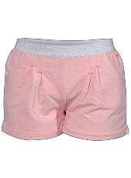 | LIGHT PINK | 67 | € 24,95
 | 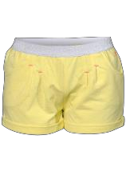 | LIGHT YELLOW | 78 | € 24,95

STYLE | PHOTO | COLOUR | QUANTITY | RRP
ACHRO-G-34-O |  | LIGHT LILAC | 29 | € 29,95
 | 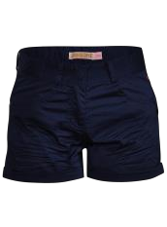 | NAVY | 1 | € 29,95
ACHRO-G-37-D | 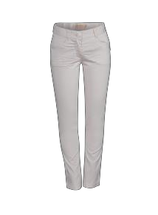 | LIGHT LILAC | 162 | € 39,95
 | 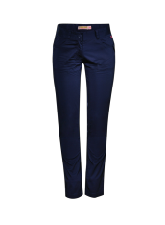 | NAVY | 62 | € 39,95
ACHRO-SG-02-E | 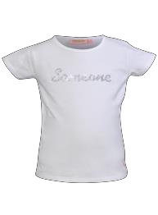 | WHITE | 14 | € 14,95
ACHRO-SG-02-I | 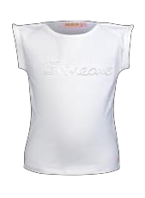 | WHITE | 7 | € 17,95
ACHRO-SG-34-G |  | CORAL | 22 | € 24,95
 |  | ECRU | 128 | € 24,95
 |  | LIGHT YELLOW | 23 | € 24,95
 |  | OLD PINK | 1 | € 24,95

Seite 2 von 11
STYLE PHOTO COLOUR QUANTITY RRP

ACHRO-SG-34-O LIGHT LILAC 135
€ 24,95

ACHRO-SG-37-D LIGHT LILAC 37
€ 34,95

BALLO-G-34-Y CORAL 24
€ 29,95

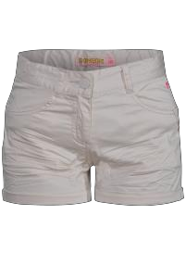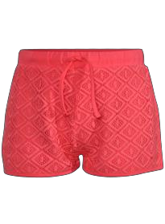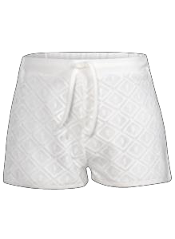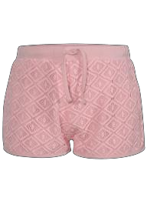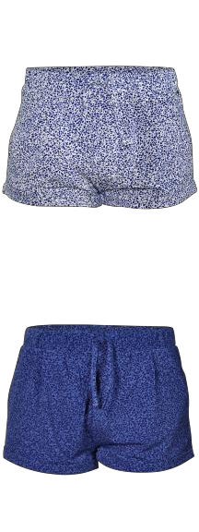ECRU 72
€ 29,95

OLD PINK 42
€ 29,95

BALLO-G-34-Z ECRU 74
€ 24,95

JEANS BLUE 57
€ 24,95
STYLE P COLOUR QUANTITY RRP

HOTO

BALLO-G-37-A | ECRU | 82 | € | 34,95

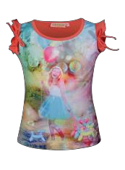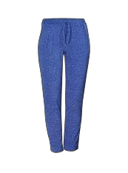
JEANS BLUE | 106 | € | 34,95

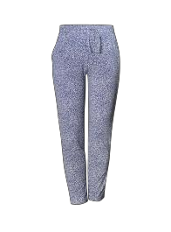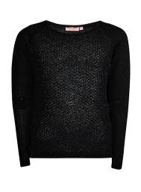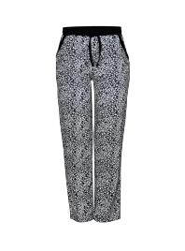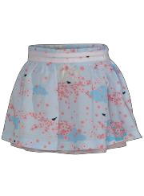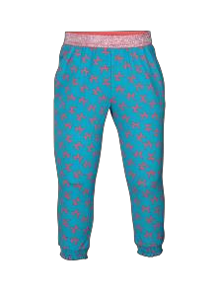
BALLO-SG-02-Z | MEDIUM CORAL | 30 | € | 24,95

BALLO-SG-37-D | MEDIUM AQUA | 30 | € | 24,95

BLACK-G-15-X | BLACK | 244 | € | 34,95

BLACK-G-37-A | BLACK | 1 | € | 29,95

BLOSSOM-SG-41-F | LIGHT PINK | 54 | € | 29,95
BLOSSOM-SG-50-G | PINK | 98 | € | 39,95
BLOSSOM-SG-51-I | AQUA | 111 | € | 39,95

STYLE | PHOTO | COLOUR | QUANTITY | RRP
BLUSH-G-41-C |  | MINT | 28 | € -
BLUSH-G-50-A |  | OLD PINK | 99 | € 39,95
BLUSH-G-50-B | 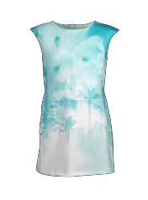 | MINT | 54 | € 39,95
BLUSH-G-50-E |  | OLD PINK | 144 | € 39,95
CACTUS-G-37-A |  | ECRU | 68 | € 29,95
CACTUS-G-41-Y |  | ECRU | 28 | € 29,95
 |  | NAVY | 21 | € 29,95

Seite 5 von 11
STYLE PH COLOUR QUANTITY RRP

CACTUS-SG-02-F | GREEN | 45 | € | 19,95

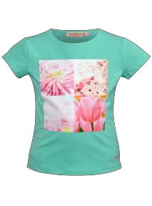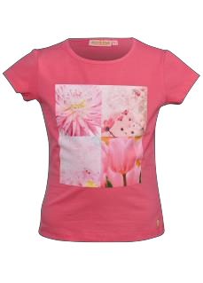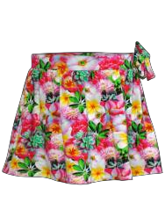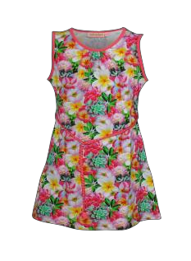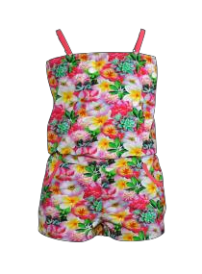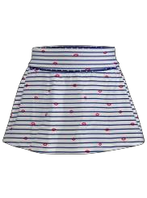PINK 117
€ 19,95

OTO

CACTUS-SG-41-D | CORAL | 339 | € | 29,95

CACTUS-SG-50-B | CORAL | 617 | € | 34,95

CACTUS-SG-64-G | CORAL | 151 | € | 34,95

CHER-SG-41-L | WHITE | 150 | € | 29,95
HAPPY-SG-01-N | LIGHT CORAL | 21 | € | 14,95
HAPPY-SG-02-B | AQUA | 21 | € | 19,95
 | OLD PINK | 27 | € | 19,95
HAPPY-SG-02-I | LIGHT CORAL | 25 | € | 19,95
HAPPY-SG-34-T | WHITE | 48 | € | 24,95

STYLE PHOTO COLOUR QUANTITY RRP

HEAVEN-SG-34-J WHITE 417
€ 29,95

HEAVEN-SG-41-C WHITE 361
€ 29,95

LEAF-SG-02-A CORAL 27

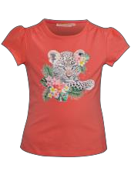LEAF-SG-02-B MEDIUM CORAL 69
€ 24,95

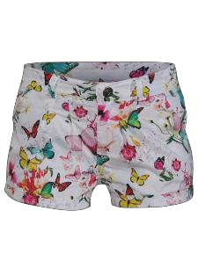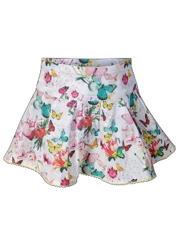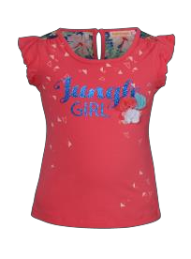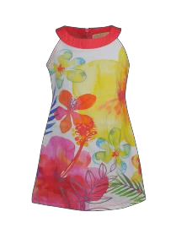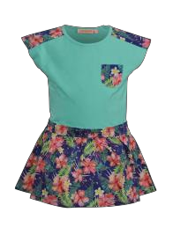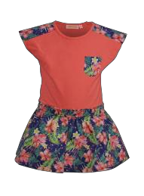€ 19,95

LEAF-SG-50-F MEDIUM CORAL 1.340
€ 39,95

LEAF-SG-51-C GREEN 46
€ 34,95

MEDIUM CORAL 207
€ 34,95
STYLE PHOTO COLOUR QUANTITY RRP

MMM-SG-51-B PINK 153
€ 34,95

MMM-SG-64-D PINK 86
€ 34,95

PIOEN-SG-01-K ECRU 95
€ 17,95

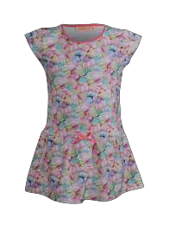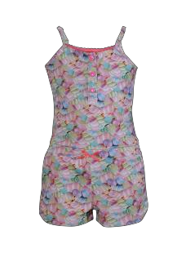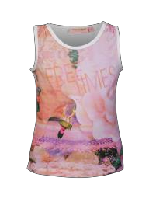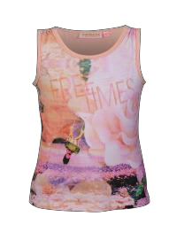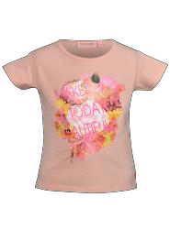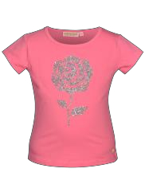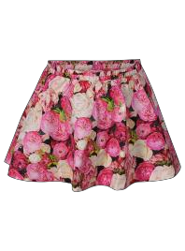LIGHT CORAL 260
€ 17,95

PIOEN-SG-02-F LIGHT CORAL 47
€ 14,95

PIOEN-SG-02-M PINK 18
€ 17,95

PIOEN-SG-41-A PINK 46
€ 34,95

OTO
STYLE | PH | COLOUR | QUANTITY | RRP
PIOEN-SG-50-D | 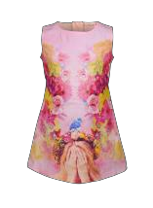 | LIGHT CORAL | 40 | € 34,95
PRETTY-SG-51-B | 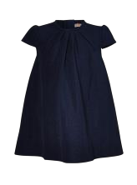 | DARK BLUE | 190 | € 29,95
REEF-SG-01-G |  | MEDIUM CORAL | 27 | € 19,95
REEF-SG-41-B |  | MEDIUM CORAL | 81 | € 24,95
REEF-SG-41-E | 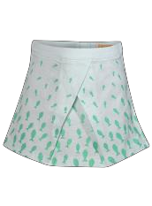 | LIGHT MINT | 608 | € 29,95
 |  | MEDIUM CORAL | 740 | € 29,95
REEF-SG-50-A | 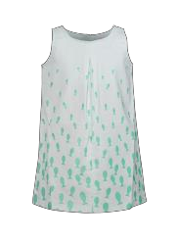 | LIGHT MINT | 171 | € 39,95

Seite 9 von 11

STYLE | PHOTO | COLOUR | QUANTITY | RRP
 | 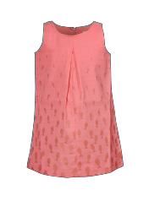 | MEDIUM CORAL | 478 | € 39,95
REEF-SG-50-C | 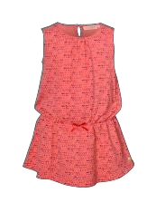 | MEDIUM CORAL | 118 | € 29,95
 |  | MINT | 116 | € 29,95
SEA-SG-02-I |  | AQUA | 44 | € 19,95
SEA-SG-41-G |  | AQUA | 147 | € 34,95
SEA-SG-50-D |  | AQUA | 126 | € 39,95
SEA-SG-51-A | 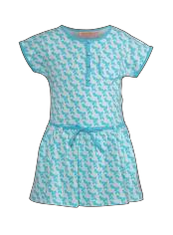 | AQUA | 141 | € 29,95

Seite 10 von 11

STYLE | PHOTO | COLOUR | QUANTITY | RRP
SOFT-SG-02-A | 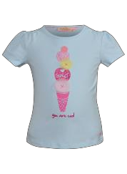 | L BLUE | 443 | € 19,95
 |  | L YELLOW | 158 | € 19,95
 |  | WHITE | 252 | € 19,95
SOFT-SG-34-D |  | LIGHT PINK | 16 | € 24,95
SOFT-SG-41-C |  | LIGHT PINK | 159 | € 27,95
SWEET-SG-50-B |  | LIGHT YELLOW | 254 | € 39,95
TUCAN-SG-02-E |  | MEDIUM CORAL | 27 | € 19,95
UNI-SG-33-J |  | MEDIUM DENIM BLUE | 47 | € 34,95
Total |  |  | 11.727 | € 31,82

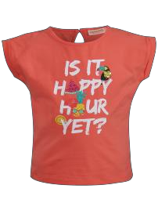

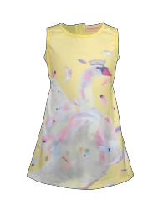Seite 11 von 11

